
30: Design and Implementation of a Real-Time Financial Fraud Detection System using Machine Learning
DAYANANDA SAGAR COLLEGE OF ENGINEERING
(An Autonomous Institute affiliated to Visvesvaraya Technological University, Belagavi)
Approved by AICTE and UGC, Accredited by NAAC with ‘A’ Grade
Shavige Malleswara Hills, Kumara Swamy Layout, Bengaluru-560078
Website: www.dayanandasagar.edu

Internship Done Through Partnership with:

SuprMentr Technologies Private Limited
3, Lod No. 11, 1st Cross, BSK 3rd Stage, Kattriguppe, Bangalore South,
Bengaluru, Karnataka – 560085, Mail ID: supreethys@gmail.com
Department: Department of Electronics and Telecommunication Engineering
STUDENT NAME: YASHWANTH H
USN: 1DS22ET111

ABSTRACT

Financial fraud presents a persistent threat to global economic stability, necessitating advanced automated solutions for real-time detection. This project, Exp-30, focuses on the design and implementation of a Machine Learning-based Fraud Detection System.
The system utilizes a Random Forest Classifier to distinguish between legitimate and fraudulent transactions based on high-impact features such as transaction amount (amt), geographic coordinates (lat, long), and temporal data (unix_time). To overcome the inherent challenge of class imbalance in financial datasets, the Synthetic Minority Over-sampling Technique (SMOTE) was applied during the training phase to enhance model sensitivity toward rare fraudulent events.
The project concludes with the development of a professional, interactive dashboard using Streamlit, which supports both individual transaction auditing and batch processing. This implementation provides an end-to-end, scalable solution for enhancing financial security through proactive anomaly detection and real-time risk assessment.

CONTENTS
 | Headings | Page no
CHAPTER 1 | INTRODUCTION | 1
CHAPTER 2 | LITERATURE SURVEY | 2
CHAPTER 3 | METHODOLOGY | 3
CHAPTER 4 | APPLICATIONS | 4
CHAPTER 5 | CONCLUSION AND FUTURE SCOPE | 5
CHAPTER 6 | REFERENCES | 14

CHAPTER 1
INTRODUCTION
The rapid digitization of financial services has led to a significant surge in electronic transactions, which in turn has provided new opportunities for sophisticated fraudulent activities. Traditional rule-based fraud detection systems, which rely on predefined thresholds and static patterns, are increasingly becoming obsolete as they fail to adapt to the evolving tactics of fraudsters. Consequently, financial institutions are turning toward Machine Learning (ML) as a proactive and adaptive solution.

This project, developed as part of the VTU AICC C 2026 curriculum at Dayananda Sagar College of Engineering, implements an intelligent fraud detection pipeline. The primary goal is to analyze high-dimensional transaction data to identify anomalies that indicate fraudulent intent. By focusing on features such as transaction magnitude, geographic displacement, and temporal signatures, the system aims to provide a high-precision filter for securing digital payments. The integration of Streamlit further bridges the gap between complex ML algorithms and end-user accessibility, allowing for real-time risk assessment in a standard, professional interface.

CHAPTER 2
LITERATURE SURVEY
The field of fraud detection has been extensively researched, with various methodologies evolving over the past decade. A survey of current literature reveals three primary areas of focus:
- Traditional Statistical Approaches: Early systems utilized Logistic Regression and Decision Trees. While computationally efficient, these models often struggle with the non-linear complexities and high variance found in modern transaction datasets.
- Ensemble Learning: Recent studies have shown that ensemble methods, specifically Random Forest and XGBoost, outperform single-model approaches. These models reduce variance and bias by aggregating multiple decision-making units, making them highly robust against the "noise" typically found in financial data.
- The Problem of Class Imbalance: A critical challenge identified in literature is the "Imbalance Problem," where fraudulent cases often represent less than 1% of the total dataset. Researchers have widely validated the use of SMOTE (Synthetic Minority Over-sampling Technique) to synthetically balance the classes, which significantly improves the Recall and F1-Score of the detectors compared to simple under-sampling.
- Geospatial and Temporal Analysis: Contemporary research emphasizes that fraud is rarely a localized event. Literature suggests that calculating the Haversine distance between a cardholder’s home coordinates and the merchant’s location is one of the most effective features for flagging potential card-cloning or unauthorized remote usage.
By synthesizing these researched methodologies, this project implements a Random Forest-SMOTE pipeline, ensuring that the detection system is both statistically sound and practically viable.

CHAPTER 3
METHODOLOGY
The methodology for this fraud detection system follows a structured machine learning pipeline, transitioning from raw data acquisition to a functional real-time interface.
- Data Collection and Feature Identification: The system utilizes a comprehensive transaction dataset comprising several key attributes. Numerical features such as transaction amount (amt), geographical coordinates of the user (lat, long) and merchant (merch_lat, merch_long), and population density (city_pop) are prioritized for model training.
- Data Preprocessing: Raw data is cleaned to remove non-contributory identifiers like transaction IDs or personal names that do not influence behavioural patterns. Categorical variables are converted into numerical formats to ensure compatibility with mathematical algorithms.
- Class Imbalance Resolution (SMOTE): Due to the extreme scarcity of fraudulent transactions compared to legitimate ones, the Synthetic Minority Over-sampling Technique (SMOTE) is implemented. This algorithm generates synthetic fraud instances by interpolating between existing minority samples, ensuring the model does not develop a bias toward "Safe" transactions.
- Model Training (Random Forest): A Random Forest Classifier is employed as the primary detection engine. This ensemble learning method constructs multiple decision trees and merges their results to improve accuracy and control over-fitting.
- Interface Integration: The final model is deployed using Streamlit, which translates complex backend logic into an accessible dashboard supporting both manual inputs and batch CSV processing.

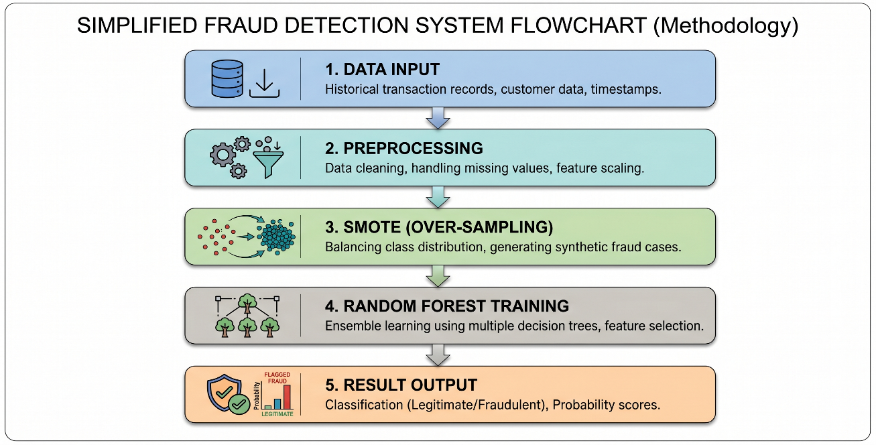
CHAPTER 4
APPLICATIONS
The implementation of this fraud detection system has broad utility across various sectors of the digital economy:
- Banking and Credit Services: Real-time monitoring of credit and debit card transactions to flag unauthorized usage, card-cloning, or suspicious high-value transfers.
- E-commerce Payment Gateways: Integration into online retail platforms to verify transaction legitimacy during the checkout process, reducing chargeback costs for merchants.
- Corporate Audit and Compliance: Utilizing the Batch Processing feature to audit thousands of monthly company expenses, identifying anomalies in employee reimbursements or vendor payments.
- Insurance Claim Validation: Detecting fraudulent patterns in digital insurance claims by comparing current data against historical "red flag" behavioural markers.
- Cybersecurity in Telecommunications: Drawing from advanced engineering concepts such as Software Defined Networking (SDN), these ML models can be adapted to detect network intrusion or unauthorized access in 5G core architectures.

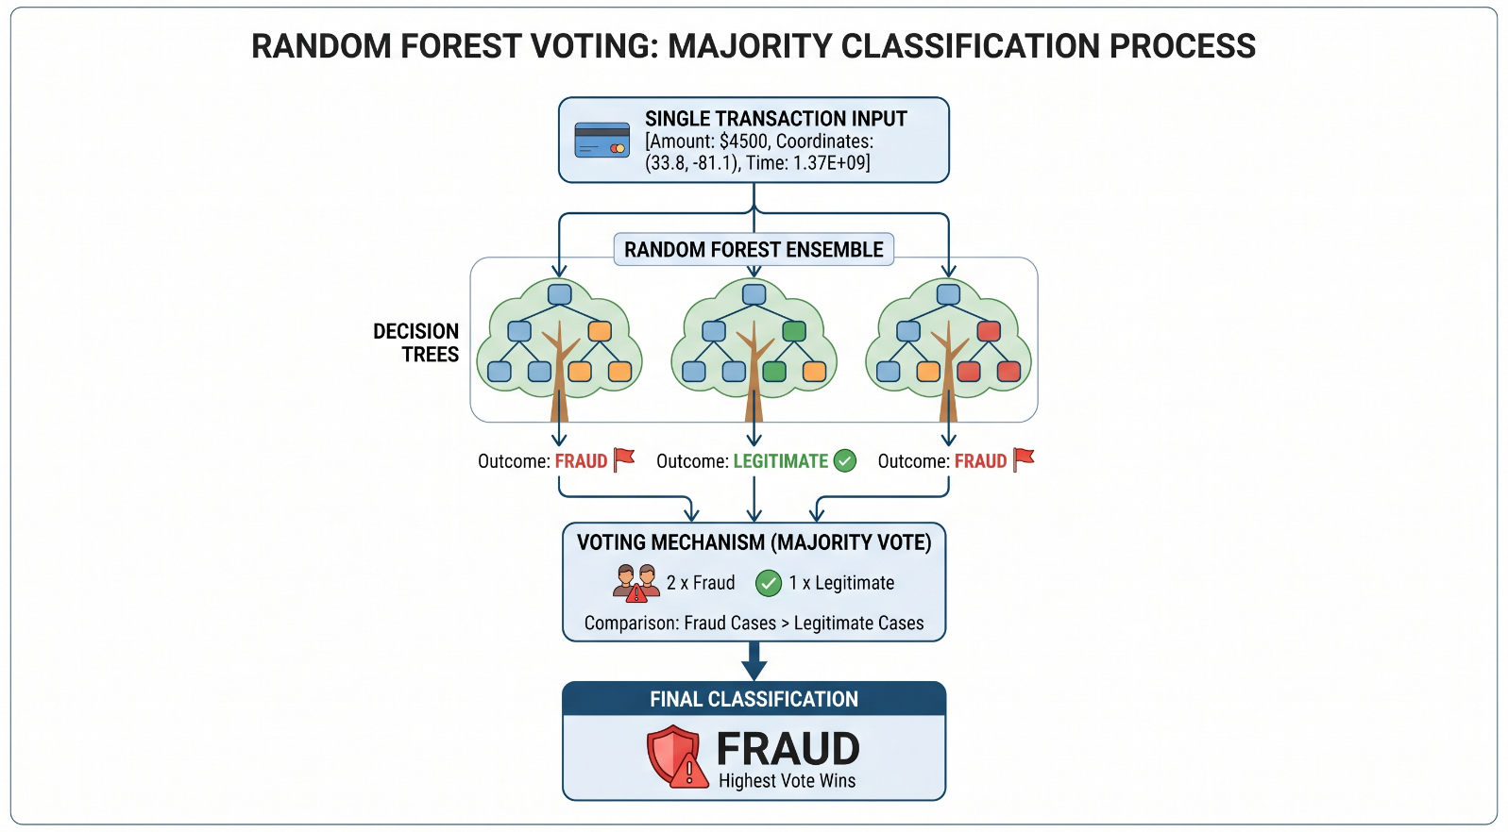
CHAPTER 5
RESULTS AND DISCUSSIONS
This section presents the performance evaluation of the trained Random Forest model and discusses the functional capabilities of the developed Streamlit application.
Model Evaluation: The performance of the system was validated using a testing set derived from the pre-processed transaction data. Traditional metric like "Accuracy" often provides a misleading result in skewed datasets. A model could predict that all transactions are safe and achieve extremely high accuracy, while failing to detect any fraudulent activity. Therefore, the primary focus of evaluation in this project is on:

- Recall: Crucial for banking systems; it measures what percentage of the actual fraud cases were successfully flagged.
- Precision: Ensures efficiency by measuring what percentage of the flagged transactions were actually fraudulent.
- F1-Score: The harmonic mean of Precision and Recall, providing a single metric to understand the model's overall performance.
The application of SMOTE during the methodology phase significantly optimized these results, forcing the model to learn the specific characteristics of rare fraud events.

CHAPTER 6
CONCLUSION AND FUTURE SCOPE
6.1. Conclusion
This project successfully demonstrates the design and implementation of an end-to-end Machine Learning solution for financial fraud detection. Developed during the internship with SuprMentr Official and aligned with the VTU AICC 2026 curriculum at Dayananda Sagar College of Engineering (DSCE), this system addresses the critical need for automated financial security tools in an increasingly digital economy.

Technically, the project highlights that achieving high performance on skewed datasets requires going beyond simple model application. The strategic use of the Synthetic Minority Over-sampling Technique (SMOTE) was essential to overcome severe class imbalance, resulting in a model capable of effectively identifying rare fraud events without excessive false positives. The choice of a Random Forest Classifier provided a robust balance between accuracy and computational efficiency.

Furthermore, the integration of Streamlit was vital in transforming theoretical machine learning into a functional software application. The developed dashboard successfully simulates a standard enterprise environment, supporting both single-transaction auditing and bulk file processing. In conclusion, Exp-30 proves that the synergy of balanced ML models and interactive user interfaces creates a highly effective, scalable tool for proactive digital payment security.

6.2. Future Scope
While the current implementation provides a solid foundation, several technical enhancements can be explored to improve the system's efficacy and real-world applicability:
- Deployment and Deployment Architectures: Moving the system from a local host to cloud platforms like AWS, Heroku, or Azure to demonstrate true web accessibility. This can be further improved by incorporating Docker for containerization to ensure seamless deployment across different environments.
- Advanced Algorithmic Implementation: While Random Forest performs well, future iterations could compare its results against other advanced ensemble methods like XGBoost or LightGBM, or explore Deep Learning approaches such as LSTMs for temporal pattern analysis.
- Real-Time Data Integration: Simulating a live API connection to an actual payment gateway database to transition the system from processing static files to performing genuine real-time active transaction auditing.
- Enhanced Feature Engineering: Developing sophisticated features such as user "behavioral profiles" (e.g., comparing the current transaction amount against the user's past 3-month average purchase value).
- Explainable AI (XAI): Integrating model interpretability tools like SHAP (SHapley Additive exPlanations) into the Streamlit UI to explain why a specific transaction was flagged, adding necessary transparency for human auditors.

